***BEEE LAB EVALUATION PHASE 1***

**Circuit Diagram:**

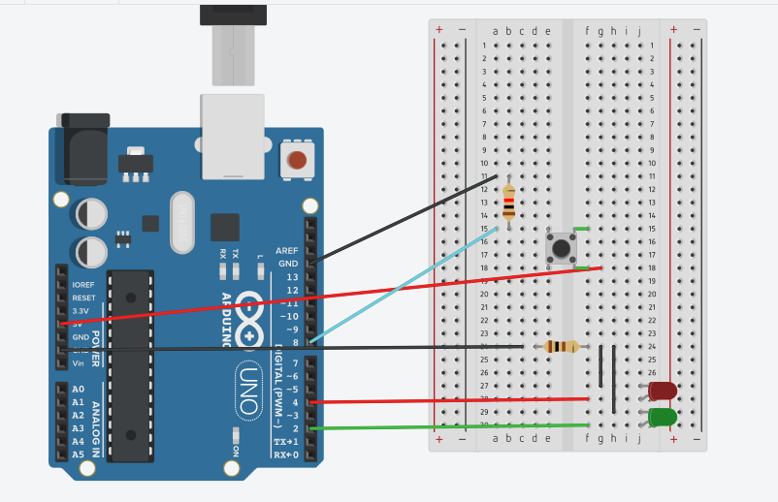

**Theory**

Concept Used: Design a system for washing machines such that whenever it is filled, a Red LED turns on and if it is empty, a Green LED blinks once every 20 ms.

Learning & Observations: when the machine is filled the button is pressed due to pressure and the red LED will glow and if the machine is empty the green LED will blink .

Problems & Troubleshooting: LED was found to be fused and Arduino can be faulty and it can be resolved by changing the elements

Precautions: Resistor should be connected to LED so that the flow of current remains low and preserves LED from damaging.

Learning Outcomes: LED is a diode having two ends P-type and N-type and glows with a very less amount of current. Arduino IDE is used to program the microprocessor in certain way given.